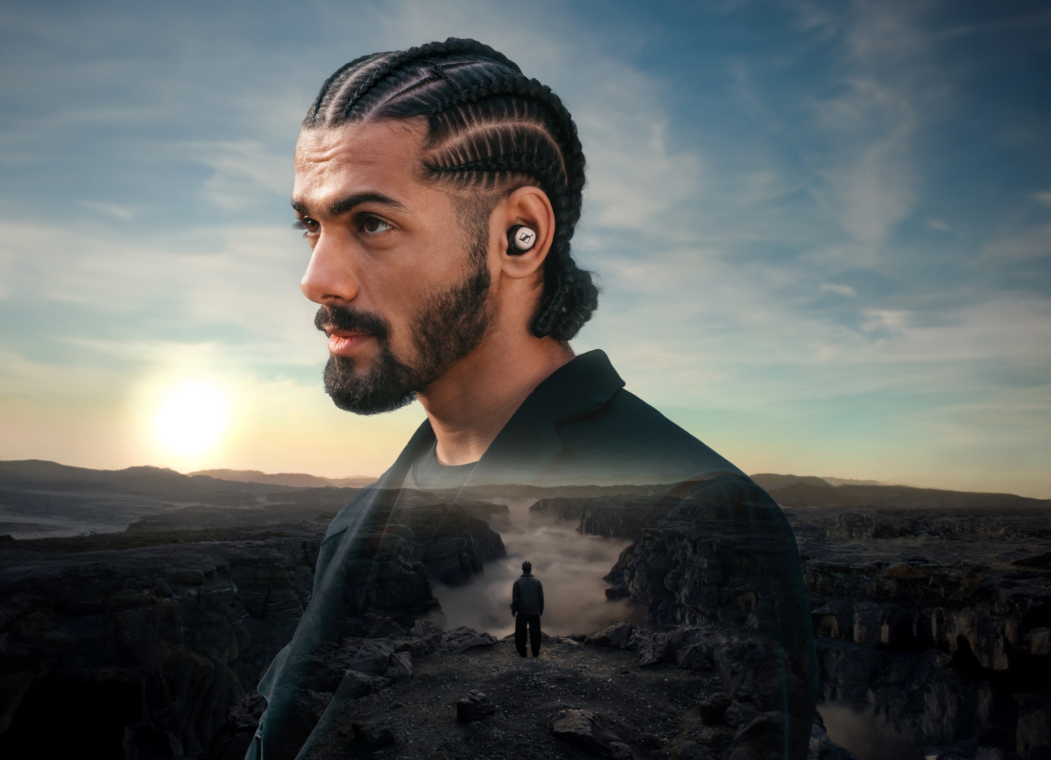
All 4 one, and one 4 all
Sennheiser officially launches the MOMENTUM True Wireless 4
Wedemark, Germany, March 1st, 2024 – After unveiling the latest generation flagship earbuds at CES 2024, the Sennheiser MOMENTUM True Wireless 4 are available from today to customers globally. Packed with over a dozen upgrades and future-facing technologies such as Snapdragon Sound™ Technology with Qualcomm® aptX™ Lossless Technology, Auracast™, and ultra-low-latency mode, the portable powerhouse series brings uncompromised sound to the high-performance audio enthusiast.
“Sound quality will always be a top priority for our customers, and we are seeing increasing demand for the application of it out in the real world,” says Frank Foppe, Sennheiser Product Manager, “With higher quality hardware and our widest range of wireless technology support ever, MOMENTUM True Wireless 4 grows with the consumer’s needs no matter how dynamic they currently are—or will become in the future.”
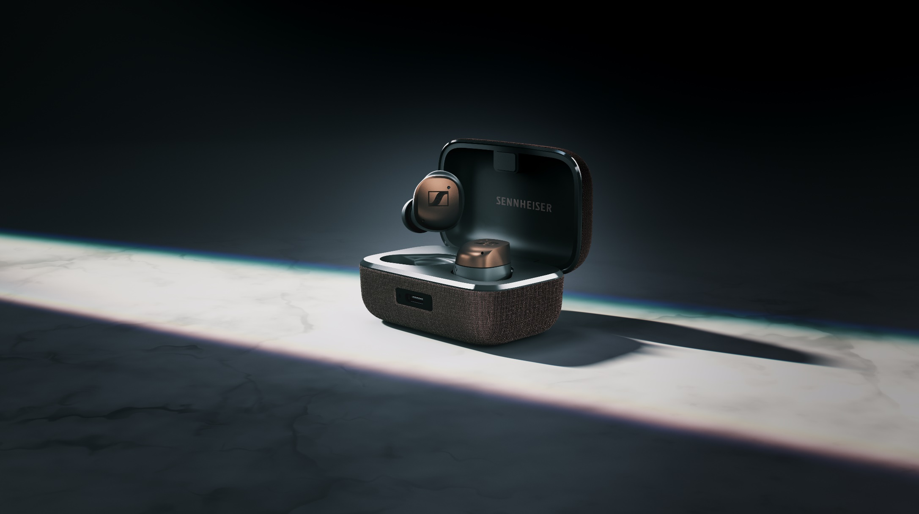
Step into the future
MOMENTUM True Wireless 4 introduces an exciting era for wireless audio, providing an unparalleled fusion of sound quality, cutting-edge features, and personalized comfort. With a commitment to user-centric innovation, it delivers a neatly tailored audio journey to a consumer demanding both individual adaptation and versatility in everyday situations. Out of the box, MOMENTUM True Wireless 4 connects you to your digital universe using Bluetooth® 5.4 to ensure next-generation performance, features, and reliability. The earbuds are built on the Qualcomm® S5 Sound Gen 2 platform with Snapdragon Sound and support for aptX Lossless as well as aptX Adaptive Audio, while Bluetooth LE Audio with LC3 and AURACAST is coming soon via a firmware update. With these features, the earbuds are equipped for the exciting possibilities of tomorrow with ultra-low-latency capable, premium sound for today.
Quite the reception
Wide support for wireless technologies is only as useful as the hardware powering it, and MOMENTUM True Wireless 4 delivers, bringing Qualcomm® RF Front End (RFFE) technology to Sennheiser’s renowned TrueResponse transducer technology. The improved antenna design brings greater RF sensitivity, improved signal-to-noise ratio and dynamic role switching faster connections and even better signal continuity while on the go. All of this happens at faster speeds than prior generations of MOMENTUM True Wireless, enabling a more natural experience when watching, communicating and even gaming on devices that put emphasis on lower-latency performance.
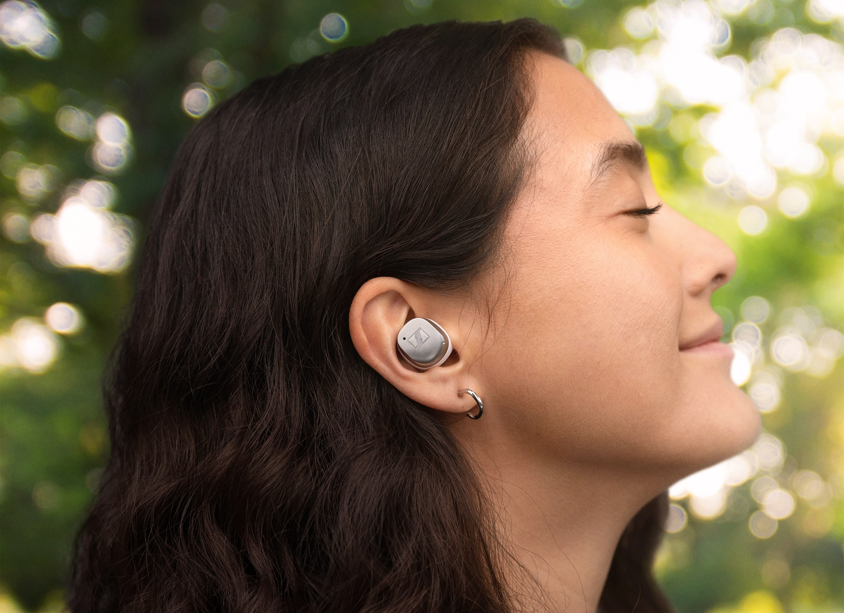
“The Qualcomm S5 Gen 2 Sound Platform and Snapdragon Sound will deliver premium sound experiences for music, calls, and gaming with lossless music streaming, ultra-low latency and robust connectivity,” said Mike Canevaro, Director of Marketing, Qualcomm Technologies, Inc. “We have a long history of collaboration with the Sennheiser brand, and we are excited to see them integrate our latest Snapdragon Sound technology to help delivery amazing wireless audio on their latest MOMENTUM True Wireless 4.”
MOMENTUM True Wireless 4 also offers up to 7.5 hours of continuous audiophile-inspired listening—extendable to 30 hours with the charging case—and quick charging capability that provide up to 1 hour of additional listening from just 8 minutes of charging. The USB-C charging case means quick and convenient replenishment virtually anywhere you take them while integrated Qi wireless charging keeps those carefully curated desktops clutter-free. To ensure maximum operating life, Sennheiser has also upgraded the earbuds’ long-term battery performance with a battery protection mode that optimizes charging cycles. The resulting longevity will give consumers more listening time over a longer lifespan with the same set of earbuds.

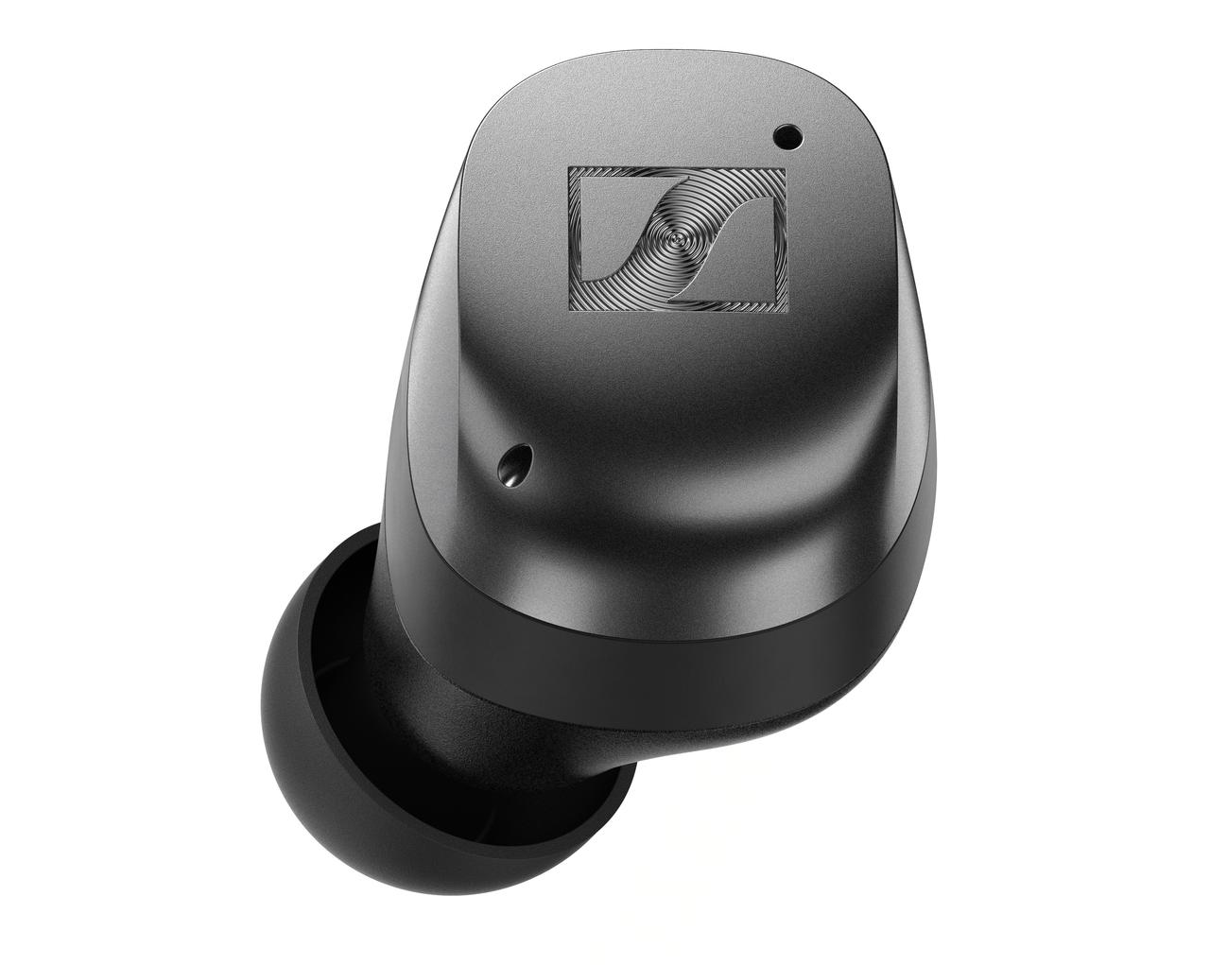
The heir up there
While the cutting-edge wireless technologies inside MOMENTUM True Wireless 4 bring impressive upgrades compared to its predecessors, Sennheiser also found ways to further enhance the acoustical experience, too. The six-microphone array improves both voice pickup and the effectiveness of the Adaptive Noise Cancelling system with faster and stronger reaction to the wearer’s environmental noise scenes. An adaptive equalizer monitors the frequency makeup of incoming audio streams for a more consistent sound across musical genres or content types such as movies, podcasts, and games, while the popular Sound Personalization, Sound Zone, and Sound Check features are brought into this new generation of hardware via the Smart Control App (iOS and Android).
Lastly, a revised ear tip and nozzle design offer better protection from earwax, letting audio enthusiasts lose themselves in the evolved tuning; smoother treble response accompanies extensive bass and effortless midrange performance typical of Sennheiser’s audiophile headphones. MOMENTUM True Wireless 4 also ships with a comprehensive fit kit, letting consumers find the perfect balance of comfort and stability using various sizes of included ear tips and ear fins—guided by a clever fit test built right into the Smart Control app, ensuring optimum bass response and noise cancelling performance for every listener.
Foppe expanded, “Beyond hundreds of millions of streaming hi-res music tracks are powerful ways to improve your life with wireless audio. Imagine interacting with museum exhibits while on vacation, then tapping into a sports television broadcasts at a noisy airport bar while awaiting your flight home, and finally enjoying a serene movie theater experience in your seat—all with one set of earbuds. MOMENTUM True Wireless 4 is already equipped to handle it all.”

The Sennheiser MOMENTUM True Wireless 4 will be available from today in three colorways; Black Copper, Metallic Silver, and Graphite for an MSRP of $299.95 USD / €299.99 EUR.

About the Sennheiser brand
We live and breathe audio. We are driven by the passion to create audio solutions that make a difference. Building the future of audio and bringing remarkable sound experiences to our customers – this is what the Sennheiser brand has represented for more than 75 years. While professional audio solutions such as microphones, meeting solutions, streaming technologies, and monitoring systems are part of the business of Sennheiser electronic GmbH & Co. KG, the business with consumer devices such as headphones, soundbars and speech-enhanced hearables became part of the Sonova Holding AG group of companies in 2022, who have licensed the Sennheiser trademark for this purpose.

www.sennheiser.com
www.sennheiser-hearing.com

Qualcomm, Snapdragon, and Snapdragon Sound are trademarks or registered trademarks of Qualcomm Incorporated. aptX is a trademark or registered trademark of Qualcomm Technologies International, Ltd.

Snapdragon and Qualcomm branded products are products of Qualcomm Technologies, Inc. and/or its subsidiaries.

Press contact
Sonova Consumer Hearing
Eric Palonen
PR and Influencers
Sennheiser Headphone and Soundbars
+1 (860) 908 1210
eric.palonen@sonova.com

